Contents

Navigating through combination forms 1

Setting the display rules 1

Using the forms for encounters 4

# Navigating through combination forms

## Setting the display rules

The combination form section has the following screen which enables us to set the display rules of the combination form

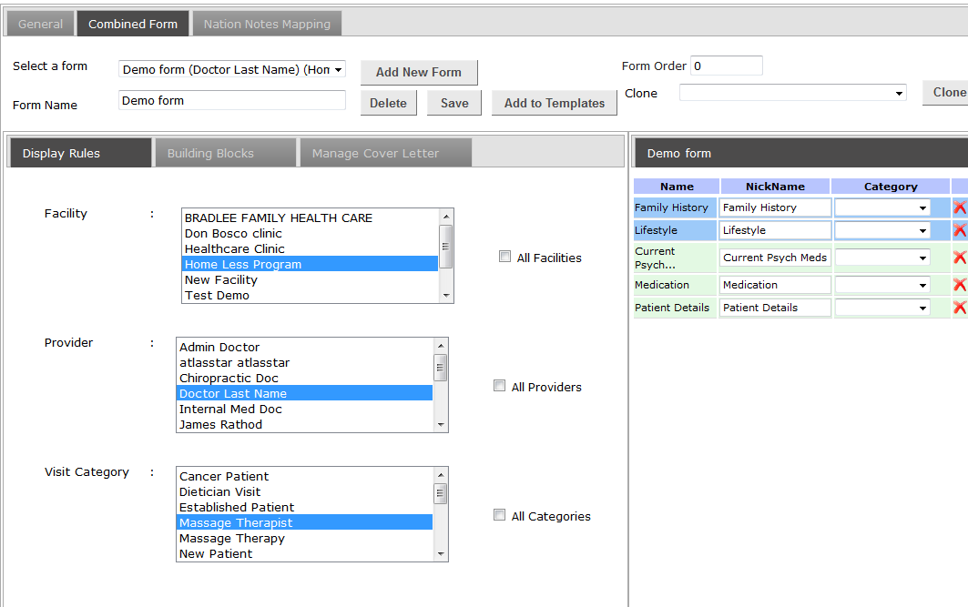

In the ‘combination form’ tab, if we click on ‘Add New Form’ (In this case we have created the ‘Demo form’), we will have the option to go to the ‘Display rules’ section, where we can set the facility, provider and visit category for a particular combination form.

We can select multiple facilities, providers and categories and this determines who will have access to the forms.

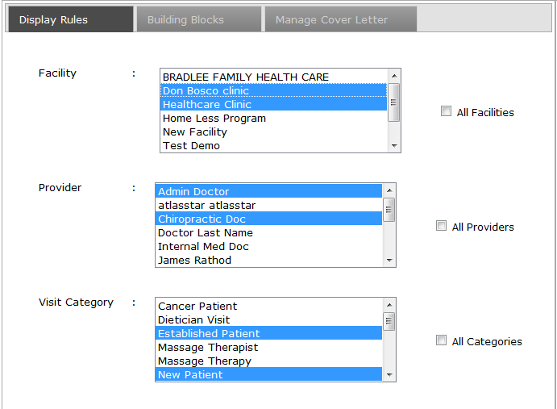

In the above screen shot, we can see the following selected

Providers: - Admin Doctor and Chiropractic doctor

This tells us that only Admin Doctor and Chiropractic doctor will be able to see the ‘Demo form’.

Facility: - Don Bosco clinic and Healthcare Clicnic.

This tells us that ‘Demo forms’ will be available only when we choose these facilities.

Visit category: - Established Patient and New Patient.

This tells us that the forms will be available only for visits which are in the above 2 categories.

Once the above setting is saved, the display rules will be frozen. We have the option to edit it at a later point of time by clicking on the edit button shown below.

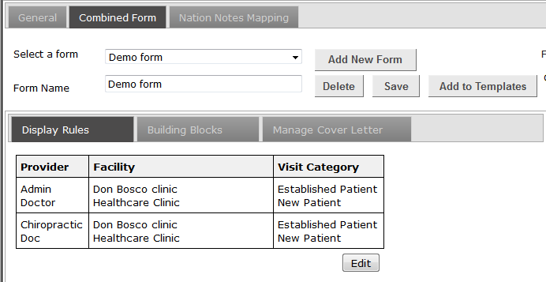

## Using the forms for encounters

We can create a new encounter for a patient by clicking on the new encounter in the patient demographics page shown below.

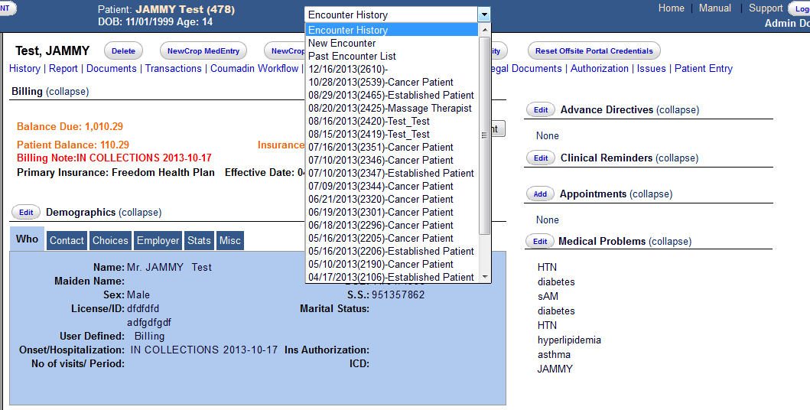

On creating a new encounter, we will be taken to the below screen. Here we can choose the visit category, Facility and Provider. Then clicking on the save button and it will take you to the forms.

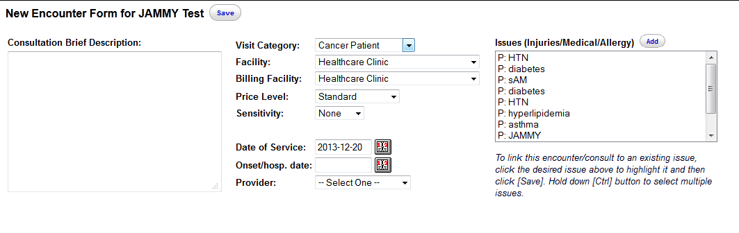

To get to the ‘Demo form’ we have to choose the

Visit category, facility and the provider.

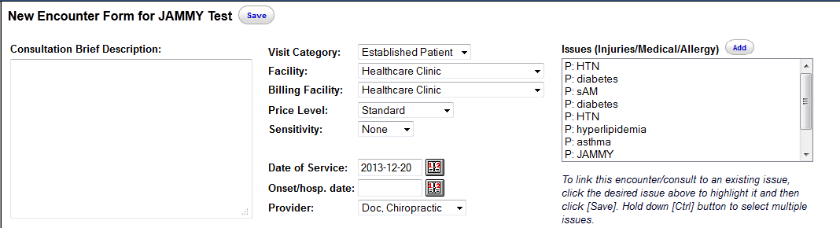

In our case we have to choose

Providers: - Admin Doctor and Chiropractic doctor

Facility: - Don Bosco clinic and Healthcare Clicnic.

Visit category: - Established Patient and New Patient.

So on choosing one of the above on visit category, facility and provider, and clicking on ‘save’ we will get to the forms. On the forms screen we will have a drop down to get to the forms that we need. This is shown below

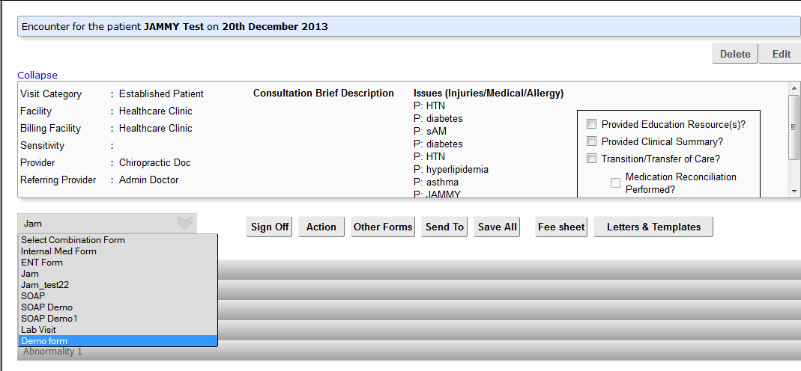

We can choose the ‘Demo form’ to be able to use it. Below we see the ‘Demo form’ selected.

